Mateen Olanrewaju February-28-2022

**Project Report**

In this project the main goal was to design the code in order to allow the user to continue to send multiple requests until the user types in Quit. So, when the user types one string it will receive it and the user should be able to continue to send strings as long as the user doesn’t type quit. Doing this I added while loop In the UDP programming if and else loop in the code in order for it to accept multiple strings. So, for the UDP sockets I used the Datagram Socket while for the TCP socket I used the Socket class and the server Socket class. I try doing it on python also but it didn’t come out great. So, I just used java instead for the project. Then after I was done with the java modified version, I made sure I ran the code and took some screenshot which are down below.

UDP:

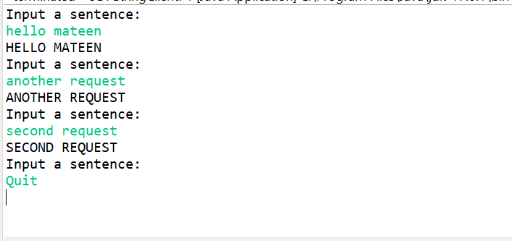

TCP:

